IWC schaffhausen

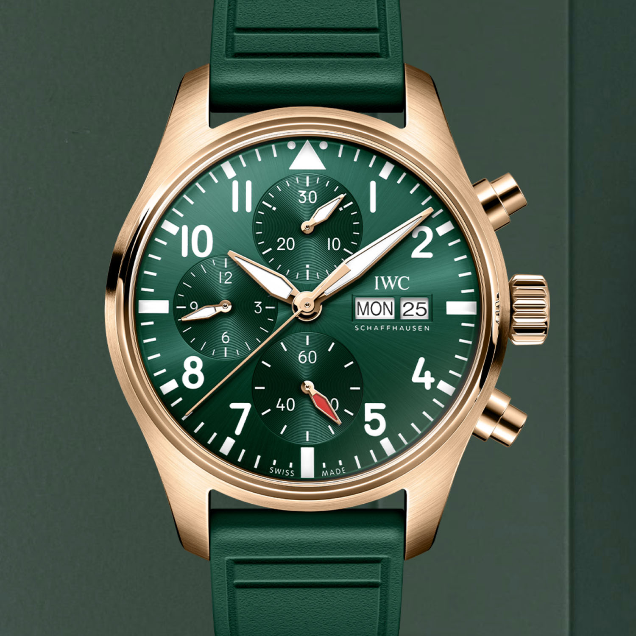DESCRIPTION: IWC Schaffhausen is a prestigious Swiss luxury watch brand known for its engineering excellence, timeless design, and precision craftsmanship. Founded in 1868 by American watchmaker Florentine Ariosto Jones, IWC combines Swiss horological expertise with innovative technology to create high-performance timepieces.

The brand is best known for its iconic collections, including the **Pilot’s Watches**, **Portugieser**, **Ingenieur**, **Aquatimer**, and **Da Vinci**. IWC is particularly celebrated for its aviation-inspired watches, featuring robust construction and legible dials. Additionally, the brand is a leader in sustainable watchmaking, focusing on ethically sourced materials and environmentally responsible production.